Sunday School 9:30
Worship 10:30
Worship Leader Tim Troyer

“To Us a Child of Hope is Born” (blue #189)

Announcements

Invocation & Prayer

“Hark! The Herald Angels Sing” (blue #201)
“It Came Upon a Midnight Clear” (blue #195)

Advent Reading & Candle-lighting: Verlyn, Gavin & Gage Dunlap

Sharing & Prayer Time

Offertory: Savannah Bontrager
Please tear off your “Response Sheet” and drop it
In the offering basket.

Scripture Reading & Message: Gene Miller
Matthew 2:13-23
“A TIME TO PONDER”

“Go Tell it on the Mountain”

What’s happening at Bellwood this week:
Wednesday, January 1 – NO Grounded Youth
Thursday, January 2 – A.A. & Alanon – 7:30
Saturday, January 4 – Men’s Prayer Breakfast – 7am

A BIG thank you to everyone who had a part in the Christmas Eve service on the 24th! Your time, and sharing your gifts, contributed to making the service a worshipful experience for all.

Please remember to make your contributions for year end giving to our treasurer, Greg Dunlap, by Tuesday, December 31, 2019. Gifts for the offering allocation account for 2020 and the remodeling project would be welcome. The Stewards

With the remodeling starting in the sanctuary, next Sunday we will
start meeting in the Fellowship Hall for church services. There will
be no livestreaming until remodeling is finished.

Authority
Proverbs 8:16 “by me princes govern, and nobles—all who rule on earth.
In the same way as the nobles and princes of old were given authority by their king to rule over an area for a period of time so are we given areas to lead. We all have been given authority to do something or to be something for a defined time. We all have a job to do. When we diligently function within our realm of authority with wisdom, then our area of responsibility will grow, and our leadership will be empowered. Wise leaders understand two principles of gain authority. The first being the recognition of their source of authority. When you know who gave you the authority to do the job then will know who or what you are accountable to. Your source of authority becomes your authority. The second principle is to know your area of authority. Know your boundaries or limits and stay within them. Knowing your source of authority and your area of authority appear to be very simple but refusing to understand and respect these principles are the source of many conflicts and wars. We have a strong tendency to desire to meddle in another person’s area. We often have a solution to someone else problem and we feel we have the responsibility to express that solution to any one that will listen. This is in actuality no different that one nobleman invading another nobleman’s land. We can that an act of war but if you do it to friend or neighbor, we call it being helpful. One of the most helpful activities you can do when given an assignment is to honor your authority and remain within your given assigned area. When we respect our given domain and honor our source of authority then both our domain and authority will increase.
The Wisdom for today – Good boundaries make good neighbors

Last Week: Worship Attendance – 95

Birthday’s this week: John Stahl (today) Roman Stauffer (Thurs.)

Worship Leader, Music & Singers:
January 5 – Worship Leader – Joy Steckly
Piano – Peg Burkey
Singers – Nick Glanzer, Katie & Val Spohn
Children’s Moment – Shelly Troyer
January 12 -Worship Leader – Austin Schweitzer
Piano – Pam Erb
Singers – Sid, Tim & Bonnie Burkey
Offertory – Gage Dunlap

Remember in Prayer:

- Doug & Shari Nelsen
- Gordon Scoville
- Search Committee
- Maintaining faith in the family

Bellwood Mennonite Church
520 B Street, Milford, NE 68405
Church Office 402-761-2709
Montessori School 402-761-3095
Email: bell606@windstream.net
Website: www.bellwoodchurch.org
Interim Pastor: Gene Miller
Associate Pastor of Youth & Pastoral Care - Taric Leichty

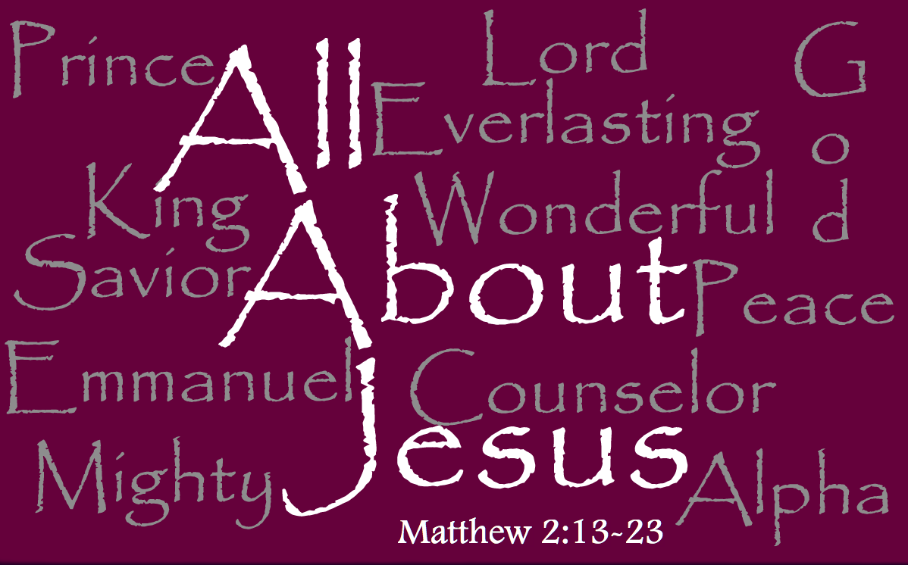

December 29, 2019

