Sunday School 9:30
Worship 10:30
Worship Leader: Konner Schluckebier

“Glorious Day”

Announcements

Invocation & Prayer

“Eye of the Storm”
“Here I Am, Lord” (blue #395) vs. 1 & 3

Sharing & Prayer Time

Offertory: Jacob Spohn

Special Music by Burkey Trio: “We’ve Come This Far by Faith”

Children’s Moment: Craig Bontrager

Scripture Reading: Genesis 12:1-9

Message: Gene Miller
“THE CALL OF ABRAHAM”

“Guide My Feet” (blue #546) vs. 1,2 & 5
^^^^^^^^^^^^^^^^^^^^^^^^^^^^^^^^^^^^^^^^^^^^^^^^^^^^^^^^^^^^^^^^^^^

Gene’s Quiz Questions:

Who was the nephew of Abraham?
Who was the father of Abraham?
(Answers in sermon)

What’s happening at Bellwood this week:
Tuesday & Wednesday – Unit 6 using Fellowship Hall
Wednesday, January 22 – Grounded Youth – Jr. 6:15-7;15
Sr. 7:30-9:00
Thursday, January 23 – A.A. & Alanon – 7:30

Registration is now open for Hesston College’s Anabaptist Vision and Discipleship Series (AVDS) on February 21 to 23. This year’s conference, in partnership with Everence Financial , is Living More with More: Redefining the Good Life, and will focus on stewardship of finances, resources and hospitality. The weekend’s content will have interest points for all life stages from high school-age youth to retirement, as well as group-focused content relatable to congregations and other organizations. Go to hesston.edu/avds for more information and registration.

Value added
Proverbs 8:19 “My fruit is better than fine gold; what I yield surpasses choice silver.”
Gold and silver have the unique ability to transfer the value of your labor from one period in time to the next without losing its value. They are also the best and fastest transfer of electrical power from one place to another. This is why they are used in phones and computers. They also cannot be destroyed by heat or manipulation, in fact the more heat and abuse they receive the purer they become. These are a few of the characteristics of Gold and silver. Now wisdom far surpasses the attributes of gold and silver because it not only transfers value but in every instance where wisdom is added it also adds value and the longer wisdom remains with a project or person the greater the increase. There is an infinite increasing to its value adding ability. There is a compounding of value that happens with every encounter of wisdom to any person or project. Wisdom needs no protection for it can absorb all the abuse and mocking it is given and still remine wise. In fact, only the abusers are change when they attempt to prove wisdom as irrelevant or unhelpful. There is nothing that can overcome its presence. This is why foolishness will flee from the wise, for if it were to remain it would be exposed and methodically changed by wisdom. In the same way silver cleans and purifies all that it meets, even more does wisdom purify and enlighten the foolish. In fact, a little wisdom added to a fool will continue to grow and will eventually take over every area it encounters.
The Wisdom for today – God’s wisdom is everywhere reviving everything

Last Week: Worship Attendance – 116, Budget - $4,968

11th Week Budget Report
Budget Giving Summary Last Week Fiscal YTD
Contributions $4,968 $65,372
Budgeted $5,336 $58,696
Over(under) ($368) $6,676

Birthday’s this week: Brody Mach (Thurs.), Jim Barker (Sat.)

Worship Leader, Music & Singers:
January 26 – Worship Leader – Paula Martin
Piano – Pam Erb
Singers – Nick Glanzer & Trisha Schluckebier
Offertory – Jess Dunlap
February 2 – Worship Leader – Katie Spohn
Piano – Pam Erb
Singers – Joy Steckly, Tony & Landon Roth
Offertory – Janice Donahue
Children’s Moment - Taric Leichty

Remember in Prayer:

- Gordon Scoville
- Search Committee
- Maintaining faith in the family
- God’s vision for Bellwood

Bellwood Mennonite Church
520 B Street, Milford, NE 68405
Church Office 402-761-2709
Montessori School 402-761-3095
Email: bell606@windstream.net
Website: www.bellwoodchurch.org
Interim Pastor: Gene Miller
Associate Pastor of Youth & Pastoral Care - Taric Leichty

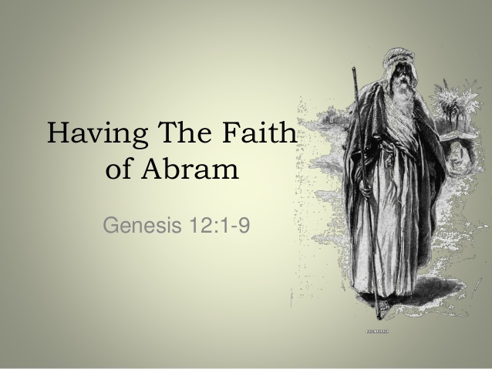

January 19, 2020

