Sunday School 9:30
Worship 10:30
Worship Leader: Joy Steckly

“Shine, Jesus, Shine”

Announcements

Invocation & Prayer

“All Hail the Power of Jesus’ Name” (blue #285

“The Love of God”

Sharing & Prayer Time

Offertory Jess Dunlap

Scripture Reading: Landon Roth
Matthew 3:13-17

Message: Gene Miller
“BAPTISM OF OUR LORD”

“May the Grace of Christ our Savior” (blue #423)
++++++++++++++++++++++++++++++++++++++++++++++++++++++

What’s happening at Bellwood this week:
Wednesday, January 15 – Grounded Youth – Jr. 6:15-7:15
Sr. 7:30-9:00
Thursday, January 16 – A.A. & Alanon – 7:30
Saturday, January 18 – Men’s Prayer Breakfast 7am

The Church Council will meet Wednesday, January 15, 7pm, in the
Fellowship Hall.

Proverbs 8:18 “With me are riches and honor, enduring wealth and prosperity.”
Wisdom and foolishness don’t dwell together for very long, for when they meet foolishness is soon exposed for what it is, silly and destructive. For foolishness to remain foolish it must leave the presence of wisdom and find the ignorant and simple minded. Those who find wisdom and remain with her will find that they are soon honored and all that they do begins to prosper. Their relationship with others grow deeper and richer. They are able to see and affirm the value in others that was previously hidden. Their ability to affirm other creates a magnetic personality that has others enjoying their companionship. Their work becomes more productive so that they can produce more in a shorter period of time. Their efficiency becomes so impressive that those around them honor them for their work and they now have more time to explore other activities to grow their knowledge and influence. When they purchase objects, they can project the long-term value of each item and they buy with value in mind. This practice stretches their money so that they have more money left over and can acquire more items or invest the excess money into income producing adventures. The wise are also thinking about potential crisis that will come and they acquire items or develop system to mitigate or eliminate the potential crisis so that when a crisis does come they are possessions well to overcome the threat. This will position them to be helpful to those around them which will deepen relationships and also may provide opportunities to profit from the crisis.

The Wisdom for today – Luck is when preparation meets opportunity

Last Week: Worship Attendance – 94, Budget - $6,383
Remodel Project - $200

Birthday’s this week: Adyline Herr (Thurs.), Jodi Roth, Bill Wiley (Fri.)

Worship Leader, Music & Singers:
January 19 – Worship Leader – Konner Schluckebier
Piano – Peg Burkey
Singers – Sid Burkey, Jeni & Khloe Bogenrief
Offertory – Spohn’s
Children’s Moment – Craig Bontrager
January 26 – Worship Leader - Paula Martin
Piano – Pam Erb
Singers – Nick Glanzer & Trisha Schluckebier
Offertory – Jess Dunlap

Remember in Prayer:

- Gordon Scoville
- Virginia Troyer’s family (her dad’s death)
- Search Committee
- Maintaining faith in the family

Bellwood Mennonite Church
520 B Street, Milford, NE 68405
Church Office 402-761-2709
Montessori School 402-761-3095
Email: bell606@windstream.net
Website: www.bellwoodchurch.org
Interim Pastor: Gene Miller
Associate Pastor of Youth & Pastoral Care - Taric Leichty

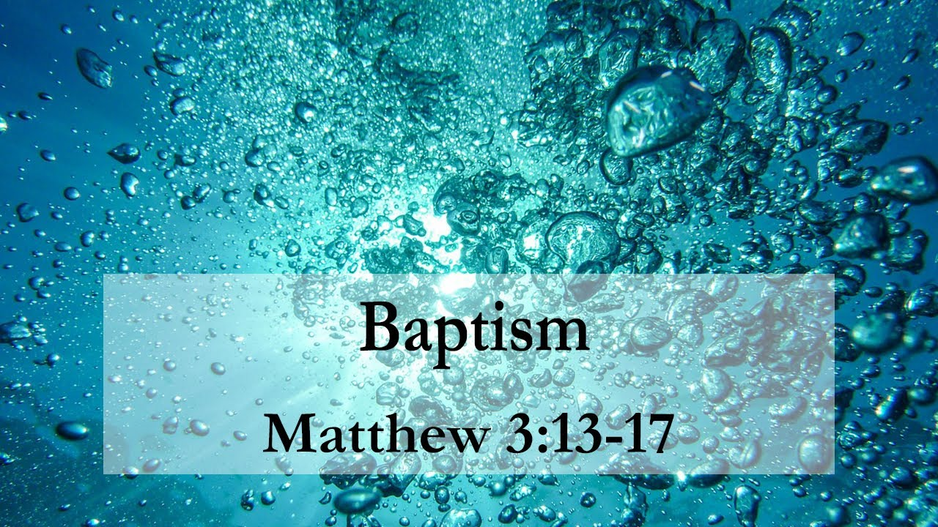

January 12, 2020

