Worship Service – 9:30
Sunday School/Fellowship Time 10:30
Worship Leader: Lisa Compton

“Enough”
“Great is Thy Faithfulness” (blue #327)

Welcome to Worship

Sharing and Prayer

Offertory: Please tear off you “Response Sheet” and drop
It in the offering basket.

Sharing from Central Plains Conference

Message: Gordon Scoville
“SIGNS AND WISE SIGHT”
John 6:25-34

“I Am the Bread of Life” (blue #472)
======================================================

What’s happening at Bellwood this week:

Monday, July 22 – Gordon’s day off
Tuesday, July 23 – Council Meeting -7pm
Thursday, July 25 – A.A. & Alanon – 7:30
Friday, July 26 – Taric’s day off

It’s school kit time at MCC and they are running low on school kit bags.
If you would be interested in making school kit bags you can review the guidelines and instructions at https://mcc.org/get-involved/kits/bag

There will be a Council Meeting Tuesday, July 23, 7pm here at the
Church.

Pastoral candidate Eugene Miller is scheduled to preach here on Sunday, August 11.

Grounded Youth! Cool off at the Milford Pool this Wednesday, July 24, during our pool party from 8-10pm! No cost to get in! JH & HS students. Bring your friends!!

Please be sure to fill out and return the Gifts Committee Affirmation
Slate when the offering is passed.

“Summer Rain”

Oh, what is so pure as the glad summer rain,
That falls on the grass where the sunlight has lain?
And what is so fair as the flowers that lie
All bathed in the tears of the soft summer sky?

The blue of the heavens is dimmed by the rain
That wears away sorrow and washes our pain;
But we know that the flowers we cherish would die
Were it not for the tears of the cloud-laden sky.

The rose is the sweeter when kissed by the rain,
And hearts are the dearer where sorrow has lain;
The sky is the fairer that rain-clouds have swept,
And no eyes are so bright as the eyes that have wept.

Last Week: Worship Attendance – 74, Budget - $8,158
Daisha’s College Fund Balance - $10,181

Birthday’s this week:

John Goertzen (today), Judy Lutgen (Mon.)

Worship Leader, Music & Singers:
July 28 – Worship Leader – Karen Bontrager
Piano – Savannah Bontrager
Singers – Joy Steckly & David Dickinson
Children’s Moment – Craig Bontrager
August 4 – Worship Leader – Joy Steckly
Piano – Pam Erb
Offertory – Katie Spohn
Singers – Nick Glanzer & Jeni Bogenrief

Remember in Prayer:

- Gordon Scoville
- Unity in our Community
- Pray for our Pastoral Candidate

Bellwood Mennonite Church
520 B Street, Milford, NE 68405
Church Office 402-761-2709
Montessori School 402-761-3095
Email: bell606@windstream.net
Website: www.bellwoodchurch.org
Interim Pastor: Gordon Scoville
Gordon’s office hours – 9-12 Tuesday – Friday
Gordon’s home phone – 761-4978
Associate Pastor of Youth & Pastoral Care - Taric Leichty

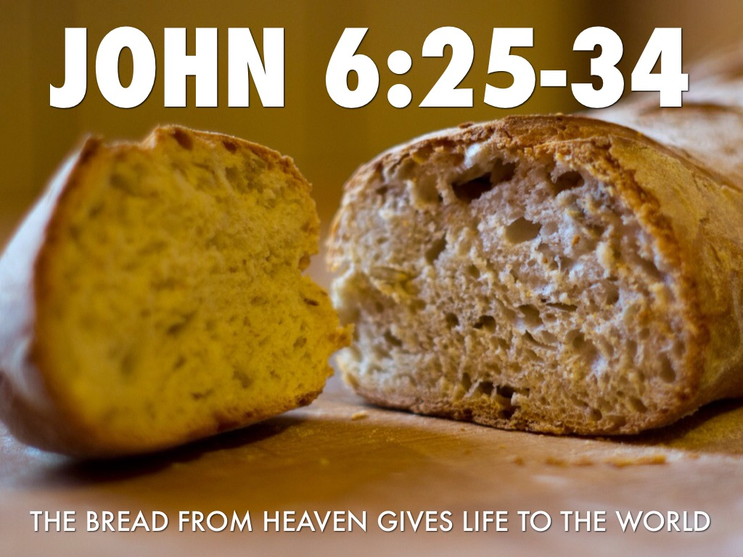

July 21, 2019

