Worship Service – 9:30
Sunday School/Fellowship Time 10:30
Worship Leader: Taric Leichty

Welcome to worship! We are blessed
by your presence with us.

“Come, thou fount” (blue #521)
“Have thine own way” (blue #504

Welcome to Worship

Sharing and Prayer

Offertory: Please tear off your “Response Sheet” and drop
It in the offering basket.

Message: Gordon Scoville
“WISE WORKING”
Genesis 2:4-9, 15

“When we walk with the Lord” (blue #544)
*********************************************************************************

What’s happening at Bellwood this week:

Monday, July 29 – Gordon’s day off
Thursday, August `1 – A.A. & Alanon – 7:30
Friday, August 2 – Taric’s day off
Saturday, August 3 – Men’s Prayer Breakfast - 7am

The Pastoral Search Committee has invited pastoral candidate Eugene Miller from Henderson to speak on Sunday, August 11th. After the service there will be a meet and greet time with the details still being worked out. Please try and make this Sunday’s service (Aug. 11th) if at all possible as it is an important time in the life of our church.

A Farmer’s Poem

‘I don’t like Poetry’
said the husband to the wife..
‘I’ve no time for such things
I live a Farmers life’
but the wife said ‘dear husband’
‘you live a poets poem’
do you not reap the harvest
of seeds by which you’ve sown?
I’ve seen you bow your head in thanks
when God answered prayers for rain
I’ve seen your eyes shine with pride
with every baby calf you name’
‘I guess poetrys okay’ he said
as he kissed that farmers wife
and silently he thanked the Lord
she saw poetry in their life…

Last Week: Worship Attendance – 61

Birthday’s this week: Kelly Newton, Jeff Oatman (Tues.)

Worship Leader, Music, Singers & Greeters:
August 4 – Worship Leader – Karen Bontrager
Piano – Pam Erb
Offertory – Katie Spohn
Singers – Nick Glanzer & Jeni Bogenrief
Children’s Moment – Craig Bontrager
August 11 – Worship Leader – Josh Milleer
Piano – Peg Burkey
Singers – Sid, Tim & Bonnie Burkey
Children’s Moment – Katie Spohn

Remember in Prayer:

- Gordon Scoville
- Russ Roth
- Unity in our community
- Our pastoral candidate

Bellwood Mennonite Church
520 B Street, Milford, NE 68405
Church Office 402-761-2709
Montessori School 402-761-3095
Email: bell606@windstream.net
Website: www.bellwoodchurch.org
Interim Pastor: Gordon Scoville
Gordon’s office hours – 9-12 Tuesday – Friday
Gordon’s home phone – 761-4978
Associate Pastor of Youth & Pastoral Care - Taric Leichty

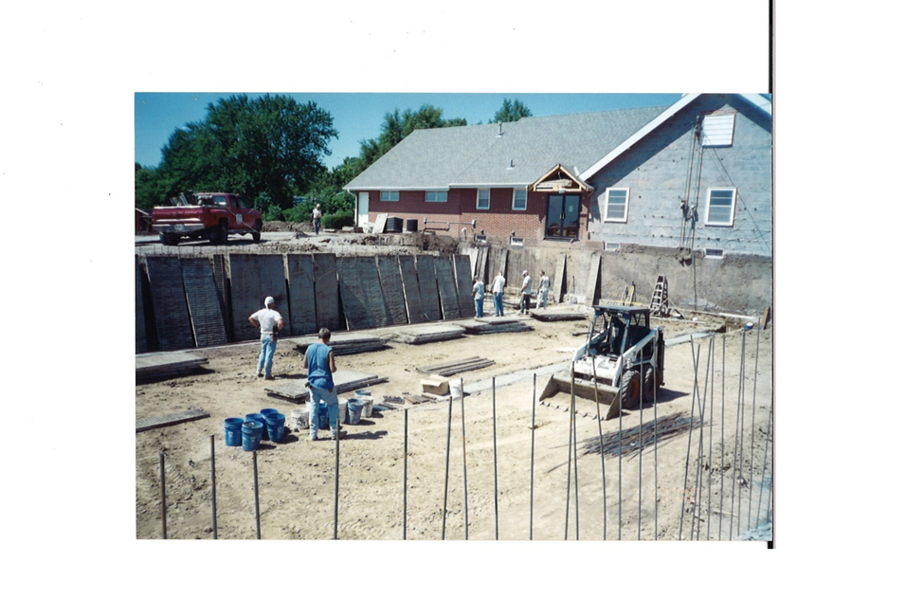

Bless Work!

July 28, 2019

