Worship Service – 9:30
Sunday School/Fellowship Time 10:30
Worship Leader: Greg Dunlap
“This is the day that the Lord has made;
let us rejoice and be glad in it.”

“O Worship the King” (blue #66)
“Joyful, Joyful, We Adore Thee” (blue #71)
“Great is thy Faithfulness” (blue #327)

Welcome to Worship

Sharing and Prayer

Offertory: Please tear off your “Response Sheet” and drop
It in the offering basket.

Message: “ONE DAY AT A TIME”

“Praise the Lord, sing hallelujah” (blue #50)
======================================================

What’s happening at Bellwood this week:
Monday, June 24 – Gordon’s day off
Wednesday, June 26 – Grounded Youth – Jr. 6:15-7:15
Sr. 7:30-9:00
Thursday, June 27 – A.A. & Alanon – 7:30
Friday, June 28 – Taric’s day off

Adult Summer Sunday School – The adult SS lesson books are under the mailboxes. There are also extra adult lesson books from previous quarters available for you to use in the library. Feel free to take one.
Thank you! Brenda Stauffer

A Memorial Service for Phyllis Burkey will be held Tuesday, June 25 at 6:00pm with dinner following. Visitation with the family will be held Monday, June 24 from 6-8pm here at the church. Group 3 is in charge of the dinner. Please let Char Roth know if you can help,
402-641-0753.

Steve Fougeron and Sid Burkey are running for Elder to replace Joy Steckly in September. Please be in prayer for these two and voting will take place next Sunday, June 30.

Carrie Maple has asked Bellwood to assist in packing 40-50 lunches for a kids lunch program that she has started this summer in the downtown park. If you can help, meet us in the church kitchen on Wednesday morning at 10:00, June 26th. Bonnie Stauffer

Coming up roses

A rose can be quite eloquent
When standing all alone;
It needs no vast accompaniment,
No pompous, royal throne,
For beauty is not always found
In suave sophistication,
But often stands just by itself
As simply God’s creation!

Last Week: Worship Attendance – 55, Budget - $2,202

Birthday’s this week: D.J. Friedli (wed.), Jan Beckler (Fri.)

Anniversaries this week: Austin & Jamie (Tues.), Josh & Kathy (Thurs.), Don & Carla (Fri.)

Worship Leader, Music, Singers & Greeters:
June 30 – Worship Leader – Katie Leichty
Piano – Peg Burkey
Singers – Nick Glanzer & Tony Roth
Children’s Moment – Katie Leichty
Greeters – Kelly & Carol Newton
July 7 – Worship Leader – Tim Troyer
Piano – Pam Erb
Offertory – Bonnie Burkey
Singers – Joy Steckly & Char Roth

Remember in Prayer:

- Gordon Scoville
- Phyllis Burkey Family
- Kim Klintworth – surgery June 25th
- Sharon Kennel – health concerns

Bellwood Mennonite Church
520 B Street, Milford, NE 68405
Church Office 402-761-2709
Montessori School 402-761-3095
Email: bell606@windstream.net
Website: www.bellwoodchurch.org
Interim Pastor: Gordon Scoville
Gordon’s office hours – 9-12 Tuesday – Friday
Gordon’s home phone – 761-4978
Associate Pastor of Youth & Pastoral Care - Taric Leichty

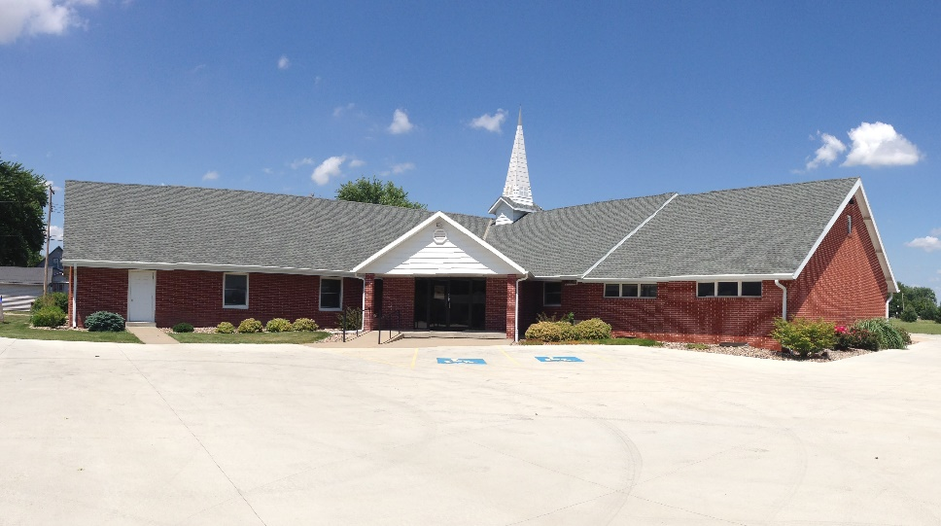

June 23, 2019

