Sunday School 9-10:00
Fellowship Time 10-10:30
Worship 10:30
Worship Leader: Katie Leichty

Call to Worship Song: “Famous One”

Announcements

Invocation & Prayer

“Mighty to Save”
“Cornerstone”

Sharing & Prayer Time

Offertory: Please tear off your “Response Sheet” and drop
It in the offering basket.

Honoring those gone before us

Reading of Scripture: Luke 19:1-10

Message: Gene Miller
“COMING UP SHORT”

“God Be With You Till We Meet Again”
======================================================

Tuesday, November 5 – Elders – 7:00
Wednesday, November 6 – Grounded Youth Jr. 6:15-7:15
Sr. 7:30-9:00
Thursday, November 7 – A.A. & Alanon – 7:30
Saturday, November 9 – Men’s Prayer Breakfast – 7am

Starry Nights will take place November 29th – December 1st. The
Milford churches are once again providing cookies for the “Sweet Shoppe”. We need 14 ladies to bake 3 dozen cookies and have them to the church by noon on Wednesday, November 27. The sign-up sheet is on the table in the overflow..

The sign-up sheet for Meat Canning food, kitchen help and housing for the canner guys is on the table in the overflow. Please have your food at the fire station by 10 a.m. on Monday, November 11.

Everyone is invited to pickup l, 2 or more Christmas Shoeboxes. They are located in the library area. If you grab a box already made up a label should be in the box. You may also grab a sheet that gives you ideas of what to put into the shoebox. We will be collecting them the last 2 Sunday’s of November. Thank You!

Truth
Proverbs 8:8 “All the words of my mouth are just; none of them is crooked or perverse.”
It was by the words of the mouth of God that all things were created and when God created all of these things they were pure and just. None of His creation was crooked or perverse. It is not until we (I) enter is there perversion. My sin or our sin corrupts God’s Word. It is a very humbling reality to understand that God’s Word would be pure and just if it were not for the fact that it has gone through me and you. It is our arrogance which deceives us into thinking that we have the truth, the whole truth and nothing but the truth. The truth is that we have partial truth and can only understand a small part of that truth. We are stuck muddling through the malaise of ignorance. Our hope is discovered not when were pursue truth but when we know the one that can speak truth and be truth. It is our relationship with God that washes the malaise of ignorance away and allows us to understand truth. Our relationship with God is a constant cleansing that demands our remaining under the presence of God. As soon as we remove ourselves from His presence we will be mucked up with our own nature and truth becomes twisted and corrupt. It has always amazed me to watch preachers illuminate scripture only to realize that God used their words to speak differently to each person. When we listen to a person share about what they learned from the sermon, often what they learned was not spoken by the preacher. The message was translated by God to the heart of the persons listening in such a way that each person heard a uniquely different message that was tailored to their personal needs. God’s Word is holy and true, but we need His Spirit to explain it to us.
The Wisdom for today – Truth is a God thing

The annual Church Forum will take place November 17 after the service. We will have a potluck lunch, followed by the Forum. Group 1 is in charge of the meal.

Last Week: Worship Attendance – 82, Budget - $6,964

Birthday’s this week: Janet Newton, Carrie Maple (Tues.),
Candace Miller, Katie Leichty (Wed.), Frank Steckly (Fri.),
Denny Peters (Sat.)
Anniversaries this week: Tom & Virginia, Travis & Tracy (Wed.)

Worship Leader, Music & Singers:
November 10 – Worship Leader – Scott Spohn
Piano – Peg Burkey
Singers – Joy Steckly, Katie & Val Spohn
Special Music – Josh Miller
November 17 – Worship Leader – Sid Burkey
Piano – Peg Burkey
Singers – Sid Burkey, Gordon & Terri Stutzman
Children’s Moment – Stephanie Svehla

Remember in Prayer:

- Russ Roth
- Cliff Irwin
- Gordon Scoville
- Strength in Marriages
- Search Committee

Bellwood Mennonite Church
520 B Street, Milford, NE 68405
Church Office 402-761-2709
Montessori School 402-761-3095
Email: bell606@windstream.net
Website: www.bellwoodchurch.org
Interim Pastor: Gene Miller
Associate Pastor of Youth & Pastoral Care - Taric Leichty

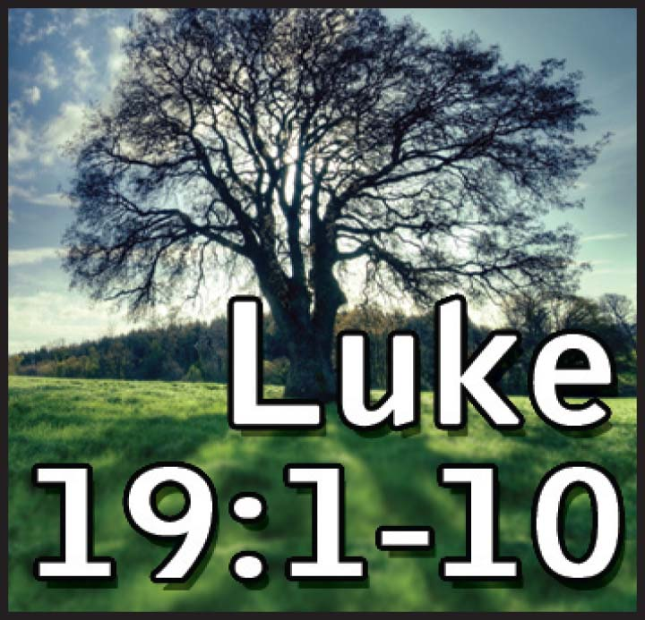

November 3, 2019

