Sunday School 9-10:00
Fellowship Time 10-10:30
Worship 10:30
Worship Leader: Darcy Friedli

Welcome to worship in the name of the Creator
who paints autumn leaves, the Savior who
teaches us to warm hearts with love, and
the Spirit who guides us through life’s seasons.

Call to Worship Song: “Wonderful Grace of Jesus: (blue #150)

Announcements

Invocation & Prayer

“Change My Heart, O God”
“Humble Thyself in the Sight of the Lord”

Sharing & Prayer Time

Offertory: Please tear off your “Response Sheet” and drop it
In the offering basket.

Reading of Scripture: Kaleb Miller
Luke 18:9-14

Message: Gene Miller
“JUDGEMENT OR GRACE”

“God Be With You Till We Meet Again”
^^^^^^^^^^^^^^^^^^^^^^^^^^^^^^^^^^^^^^^^^^^^^^^^^^^^^^^^^^^^^^^^^^^

What’s happening at Bellwood this week:
Wednesday, October 30 – Grounded Youth – Jr. 6:15-7:15
Sr. 7:30-9:00
Thursday, October 31 – A.A. & Alanon – 7:30
Friday, November 1 – Taric’s day off

HS Husker Watch Party will be at Taric and Katie’s house Saturday, November 2! Details on start time will be made known when kickoff
time is released. Please stay tuned!

Bellwood is once again going to be offering everyone the opportunity to “pack a shoebox” for Samaritan’s Purse Operation – Christmas Child.
We will be handing shoeboxes out to children in Sunday School and the Montessori Pre-School. Everyone is asked to grab a shoebox in the back of the church and fill it up. We will be collecting these shoeboxes on November 24th.

Our Lord’s mouth
Proverbs 8:7 “My mouth speaks what is true, for my lips detest wickedness.”
Truth is hard to find on the lips of men. Have you ever watched an event and then listened to someone tell about the same event and thought you had attended to different events. This happens because we don’t see activities or events from the same perspective. We are constantly viewing events through our own filter. A filter that has been filled with scares of what others have done to us. Our filter has our own preferences and emotions. Our filter has a memory of previous event that were very similar and sometimes we get events mixed up and run the two similar events together. Although it is very hard to admit we view each event through sinful glasses because we are fallen and sinful creatures. The Bible teaches us that “none are righteous, no not one”. Speaking the truth when our information is filtered through our long history of sin is nearly impossible. Our Lord’s mouth can be trusted because He was and is sinless. His motives are pure, and His judgement is unclouded. He has the ability to view our motives along with our action. He can see and understand our heart. When He speaks we immediately know it to be true because our very heart and soul confirm it to us. There is a piercing clarity about God’s voice that can not be denied. When He speaks we know, without a doubt, it to be true. After God’s voice is spoken we can then begin to accept lies that muddle our understanding but at the moment of delivery, there is no doubt. The key to maintaining the truth is to protect the truth from the lies that will bombard our thoughts and emotions.

The Wisdom for today – Truth must be engraved on our whole being and then protected by repetition.

Last Week: Worship Attendance – 109, Budget - $3,563
Meat Canning - $50

Birthday’s this week: Rich Steckly (today), Karen Stauffer (Tues.),
Jeanna Stauffer (Thurs.),Russ Roth (Sat.)

Worship Leader, Music & Singers:
November 3 – Worship Leader – Katie Leichty
Piano – Pam Erb
Offertory – Joy Steckly
Singers – Nick Glanzer & Shani Mach
Children’s Moment – Shelly Troyer
November 10 – Worship Leader – Scott Spohn
Piano – Peg Burkey
Singers – Joy Steckly, Katie & Val Spohn
Special Music – Josh Miller

Remember in Prayer:

- Russ Roth
- Cliff Irwin – surgery Wednesday, October 30
- Gordon Scoville
- Farmers at Harvest
- Strength in Marriages
- Search Committee

Bellwood Mennonite Church
520 B Street, Milford, NE 68405
Church Office 402-761-2709
Montessori School 402-761-3095
Email: bell606@windstream.net
Website: www.bellwoodchurch.org
Interim Pastor: Gene Miller
Associate Pastor of Youth & Pastoral Care - Taric Leichty

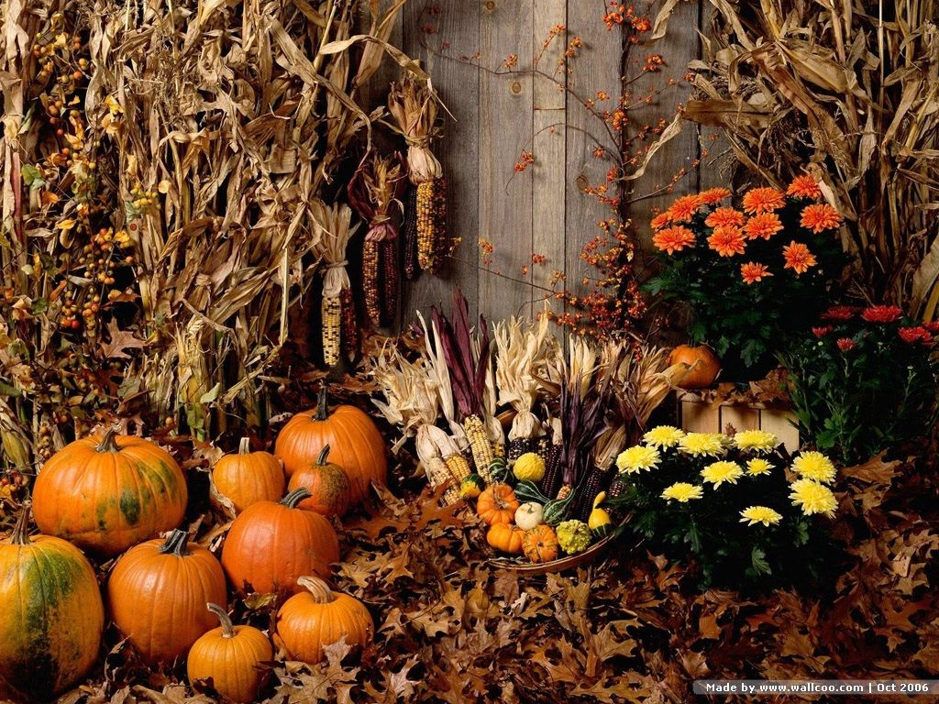

October 27, 2019

