Sunday School 9-10:00
Fellowship Time 10-10:30
Worship 10:30
Worship Leader: Jason Stahl

“Build Your Kingdom Here”

Announcements

Invocation & Prayer

“Let it Rise”
“Nothing but the blood”

Sharing & Prayer Time

Offertory: Please tear off your “Response Sheet” and drop it
In the offering basket.

Reading of Scripture: Isaac Yeackley
Luke 16:1-13

Message: Gene Miller
“A SCANDALOUS MANAGER”

“Victory in Jesus”

What’s happening at Bellwood this week:
Wednesday, September 25 – Grounded Youth – Jr. 6:15-7:15
Sr. 7:30 – 9:00
Thursday, September 26 – A.A. & Alanon – 7:30
Friday, September 27 – Taric’s day off
Saturday, September 28 – Men’s Prayer Breakfast – 7am

Baptism Class! Anyone interested In learning about or getting baptized, please contact Taric. We will begin a class this fall as several have expressed interest.

Walk through the nursery room and look at the “Sample Patch” behind the door. This is how we are considering to cover the block walls in the sanctuary.

Please fill out the “Order of Service Survey” that is in your bulletin and return to Craig Bontrager. Also, the Council decided to have the annual Budget Forum on Sunday, November 17 after the church service with a potluck dinner.

Central Plains Mennonite Conference is seeking an Executive Conference Minister with particular strengths in collaborative leadership, communication, vision setting and implementation. The leadership will guide congregations and conference leadership groups to help fulfill our mission, will lead and supervise our Ministry Staff offering guidance and support. For a more detailed description go to www.centralplainsmc.org

Charting your course
Proverbs 8:2 “At the highest point along the way, where the paths meet, she takes her stand;”
When traveling in the mountains of West Virginia, we would often come to places where the grand vision of our road ahead was displayed. The beauty of all the hills, streams, towns and roads that are set before us would provide perspective for our future adventure. Wisdom come at the highest point, as we view the big picture, where we can see the places and terrain before us. Wisdom maps out the path before it begins. It knows the destination before it starts, and it charts the desired path. Wisdom is also very attentive to intersections, where paths meet. Intersections most often come with signs calling for our attention, communicating to us that something will be crossing our path. This is where wisdom is needed. Intersections of persons and ideas can be a wonderful enhancing experience but can also be a very disappointing and vision killing experience. It is important to intersect with the right people and the right ideals. Knowing the difference between destructive ideas and positive creative ideas that enhance your success is imperative. Many a good idea are destroyed by negative thinking persons who could see only obstacles and provide only discouragement. There is a difference between persons who are negative and persons who provide warnings of potential obstacles. Negative people provide despair while person with warnings also come with potential solutions. Wisdom distinguishes the difference. Wisdom assesses which intersections to move quickly through and which intersection to stop and absorb all the knowledge and support available. We are reminded here to look for wisdom when planning the future and also when we intersect with people and ideas.
The Wisdom for today – Wisdom like God’s grace should be looked and listened for constantly.

Last Week: Worship Attendance – 89 Budget - $6,508
Scholarship - $500

Birthday’s this week: Blair Troyer (today), Dan Friedli (Tues.),
Sandra Stauffer (Wed.), Hadley McCullough, Ashton Friedli (Fri.)

Anniversaries this week: Steve & Marcy (Mon.), Don & Sheryl (Wed.), DJ & Sarene (Thurs.)

Worship Leader, Music & Singers:
September 29 – Worship Leader – Katie Spohn
Piano – Peg Burkey
Singers – Paula Martin & Josie Dick-Burkey
Special Music – Josie Dick-Burkey
October 6 – Worship Leader – Tim Burkey
Piano – Pam Erb
Offertory – Gage Dunlap
Singers – Joy Steckly, Josh & Kaleb Miller
Children’s Moment – Katie Leichty

Remember in Prayer:

- Russ Roth
- Gordon Stutzman
- Gordon Scoville

Bellwood Mennonite Church
520 B Street, Milford, NE 68405
Church Office 402-761-2709
Montessori School 402-761-3095
Email: bell606@windstream.net
Website: www.bellwoodchurch.org
Interim Pastor: Gene Miller
Associate Pastor of Youth & Pastoral Care - Taric Leichty

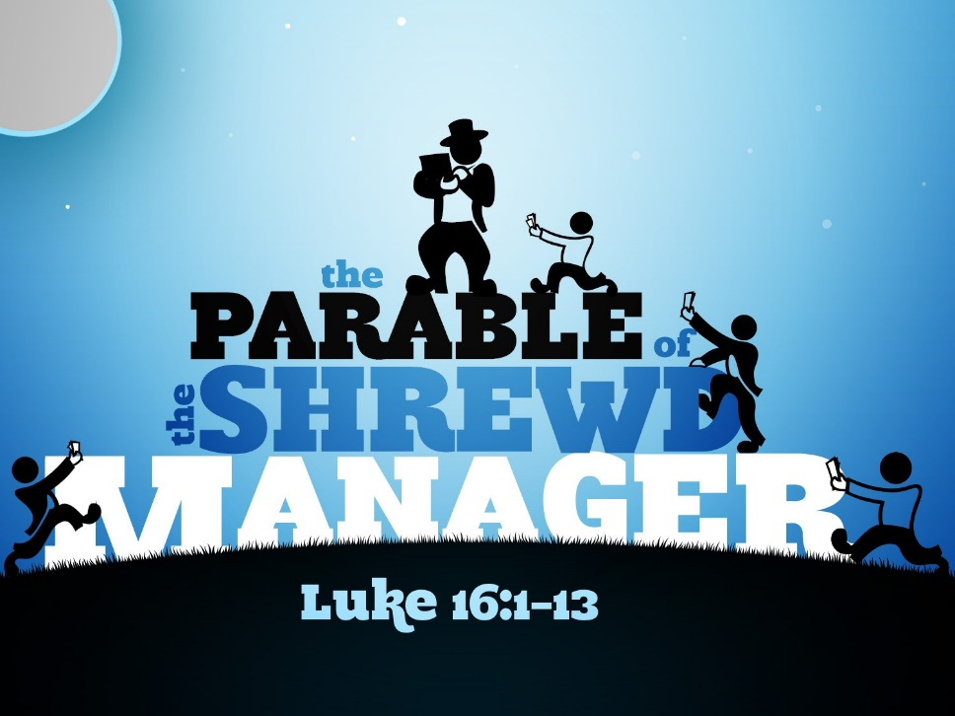

September 22, 2019

